**CourseWeb** **ACCOUNT REGISTRATION FORM**

|  |  |
| --- | --- |
| **FACULTY DETAILS** | |
| **DEPARTMENT** |  |
| **FACULTY ID** |  |
| **FULL NAME** |  |
| **QUALIFCATION** |  |
| **DESIGNATION** |  |
| **RESEARCH AREA** |  |
| **DOMAIN MAIL-ID** |  |
| **PERSONAL MAIL-ID** |  |
| **MOBILE NUMBER** |  |
| **APPLICATION DATE** |  |
| **PHOTO** | *(Send your pass-photo as an email attachment while sending application through email)* |

*** ***Domain mail-id is mandatory, Get your domain-mail first \*\*\****

*Dear faculty,*

*Please Send filled in application form to* ***[courseweb@kitsw.ac.in](mailto:courseweb@kitsw.ac.in)*** *through your domain mail-id. After your account creation, detailed login instructions will be sent back to your domain-id.*

*Thank you*

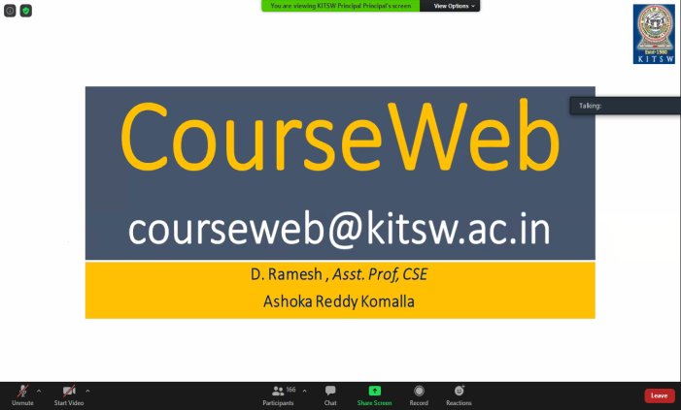

**D.Ramesh,**

***Faculty I/C, CourseWeb****.*

*Assistant Professor, CSE(N)*

*Mobile: 9491320100*