

**U24VA109 SEA/SAA**

**SOCIAL EMPOWERMENT ACTIVITY / SELF ACCOMPLISHMENT ACTIVITY**

**Report**

**on**

**SA201: Mentoring of School Children**

***(Social Empowerment Activity)***

***by***

***AKASH CHERUKU***

***B21xxxxx***

***Under the guidance of***

***C-i2RE, KITSW***



**KAKATIYA INSTITUTE OF TECHNOLOGY & SCIENCE, WARANGAL**

*(An Autonomous Institute under Kakatiya University, Warangal)*

**(2024-25)**

***Note:***

***Printing of report*** ***(print on both sides of the paper):***

* *page size: A4*
* *columns per page: one*
* *page margins : mirrored*
* *line spacing: 1.15 lines*
* *paragraph-spacing: before - 0 pt, after – 6 pt*
* *page orientation: portrait*

***Type of binding: Soft binding***

* *stack your A4 sheets evenly*
* *place transparent A4 sheets one at the top and one at the bottom of your stack*
* *staple the stack at three points (top, middle & bottom)*
* *cover the stapling with self-adhesive tape for neat appearance*

***Sample report:***

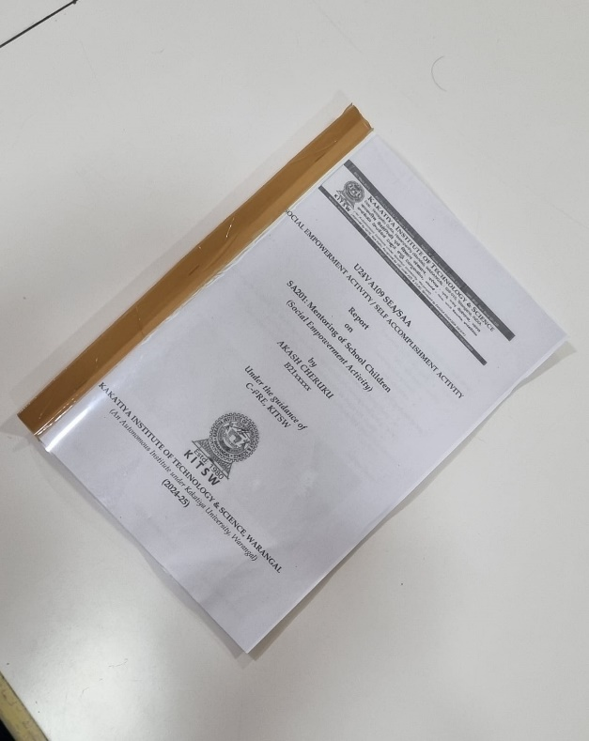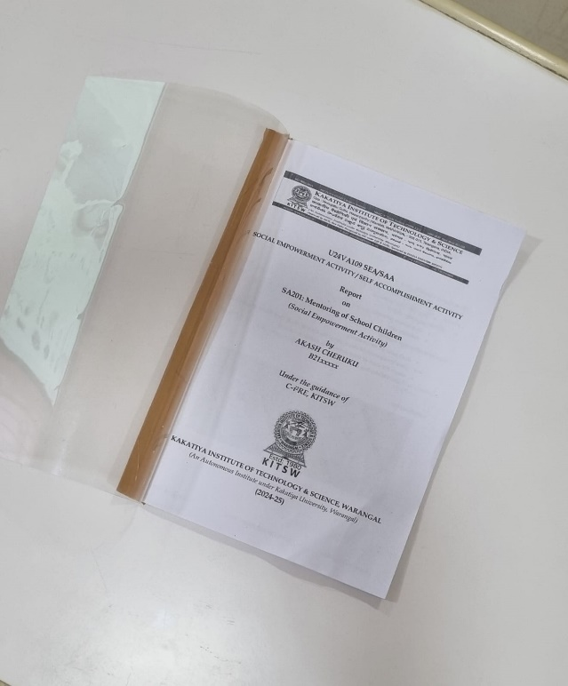

**KAKATIYA INSTITUTE OF TECHNOLOGY & SCIENCE, WARANGAL**

*(An Autonomous Institute under Kakatiya University, Warangal)*

**CERTIFICATE**

*(issued by nodal centre)*

This is to certify that, **AKASH CHERUKU** bearing **Roll No. B21XX001,** student of B. Tech, **XXX**, I Semester has successfully completed the activity ____________________________________________________ under the mentorship of Humanity Club, Student Activity Centre, KITS, Warangal.

|  |  |  |
| --- | --- | --- |
| **Faculty Counsellor** | **Mentoring Centre, SEA/SAA** | **Institute Coordinator, SEA/SAA** |

**ACKNOWLEDGEMENT**

*It is impossible to complete a project without the assistance of others, who could be your teachers, college personal, friends, eminent personalities or family members. Writing an acknowledgement customarily is a fantastic approach to appreciate everyone who assisted you in completing your task.*

* *Faculty counsellor: Thank your faculty counsellor for guiding you in finishing your job*
* *Nodal centre: Thank all the people who helped you finish your job*
* *Field work: Thank all the people who helped you at field work and finish your job*
* *Others: Thank all others who helped you in completing the activity*

*(A sample acknowledgement is attached at the end)*

***AKASH CHERUKU***

***B21xxxxx***

**CONTENTS**

|  |  |  |  |  |
| --- | --- | --- | --- | --- |
| **Chapter No.** | **Chapter Title** | | | **Page number** |
| Certificate | | | | i |
| Acknowledgement | | | | ii |
| 1 | Overview of the activity | | | 1 |
|  | 1.0 | Introduction | | 2 |
|  | 1.1 | Literature review | | 3 |
|  |  | 1.1.1 | References | 3 |
|  |  | 1.1.2 | Literature Review | 3 |
|  | 1.2 | Identified Goals | | 4 |
|  | 1.3 | Plan of action | | 5 |
| 2 | Field Work | | | 6 |
|  | 2.0 | Introduction | | 7 |
|  | 2.1 | Interaction with eminent personalities | | 8 |
|  | 2.2 | Surveys/ seminars/workshops conducted (optional) | | 9 |
|  | 2.3 | Workshops/ seminars attended (optional) | | 10 |
|  | 2.4 | Practise/ Field work carried out | | 11 |
|  | 2.5 | Summary of field work carried out | | 13 |
| 3 | Demonstration & Presentation | | | 14 |
|  | 3.0 | Introduction | | 14 |
|  | 3.1 | Demonstration/Presentation Content | | 14 |
|  | 3.2 | Feedback Analysis | | 14 |
| 4 | Key Learnings from the Activity | | | 15 |
| 5 | Self-Reflection | | | 16 |
| Appendix -A: Questionnaire for interaction with eminent personalities | | | | 17 |
| Appendix -B: Survey form adopted for collecting feedback (optional) | | | | 18 |
| Appendix -C: Plagiarism Report | | | | 19 |

**CHAPTER 1**

**Overview of the Activity**

1. **Introduction**

*(Max. 200 words)*

*In this section, you have to*

* *briefly introduce about the activity.*
* *describe the importance of the activity*
  1. **Literature review**

*(Max. 200 words)*

***1.1.1. References:***

*In this section, you have to*

* *List the references (i.e. Books, Book chapters, Journal papers, Conference Papers, Patents, etc.) you have studied/ referred in IEEE format style*

***1.1.2. Literature Review:***

*(Max. 200 words)*

*In this section, you have to*

* *Synthesize the knowledge gained from the literature you referred, related to the activity.*
* *Cite the literature you listed in 1.1.1 with proper numbering*
  1. **Identified Goals**

*(Max. 200 words)*

*In this section, you have to*

* *List the goals identified to complete the activity*
  1. **Action plan**

*(Max. 200 words)*

*In this section, you have to*

* *Give the action plan followed for achieving the goals mentioned in section 1.2. (time schedule followed week-wise for completing the activities)*

**CHAPTER 2**

**Field Work**

1. **Introduction**

*(Max. 200 words)*

*In this section, you have to*

* *briefly introduce what you did as part of fieldwork*

2.1. **Interaction with eminent personalities *(as part of field work)***

*(Max. 400 words)*

*In this section, you have to*

* *list the eminent personalities you interacted related to your activity as part of field work*
* *describe the email etiquette rules and other appropriate polite communication etiquettes you followed for getting appointment and time for interaction*
* *describe the interaction you had with the eminent personalities (their experiences, challenges faced, inputs given to you and their feedback on the current activity)*
* *include geotagged photographs taken during the interaction, as figures, with self-explanatory titles and give numbering as per format*

2.2. **Surveys/ seminars/workshops conducted *(optional, as per activity)***

*(Max. 150 words)*

*In this section, you have to*

* *describe the survey/ seminar/ workshop conducted as part of field work for your activity*
* *analyze the feedback received from the survey/ seminar/workshops*
* *include geotagged photographs taken, if any, during the conduction of the event, as figures, with self-explanatory titles and give numbering as per format*

2.3. **Workshops/ seminars attended *(optional, as per activity)***

*(Max. 150 words)*

*In this section, you have to*

* *describe the seminar/ workshop attended as part of field work for your activity*
* *describe the inputs received from the seminar/workshops*
* *include geotagged photographs taken, if any, while attending the event, as figures, with self-explanatory titles and give numbering as per format*

2.4. **Practise sessions carried out *(optional, as per activity)***

*(Max. 400 words)*

*(Practise sessions are mandatory for physical activities like SA301, SA302, SA303, SA402, SA403, SA406)*

*In this section, you have to*

* *list the places visited as part of your field work*
* *list the gurus/coaches/ people who supervised/helped your practise sessions of field work*
* *describe the practice sessions undertaken to complete your activity at these places*
* *describe the summary of logbooks/journals you maintained as part of your activity, if any*
* *include geotagged photographs taken, as figures, with self-explanatory titles and give numbering as per format (include only those photographs which are not included in previous sections)*

2.5. **Summary of field work carried out**

*(Max. 150 words)*

*In this section, you have to*

* *summarise the tasks (2.1 to 2.5) carried out to complete this activity.*

**CHAPTER 3**

**Demonstration & Presentation**

**3.0. Introduction**

*(Max. 200 words)*

*In this section, you have to*

* *list the date of demonstration/ presentation*
* *mention the place of demonstration*
* *audience attended (number only)*

**3.1. Demonstration/ Presentation Content**

*(Max. 200 words)*

*(In case of demonstration)*

*In this section, you have to*

* *provide a detailed description of how the demonstration was conducted*
* *list the experts who evaluated your demonstration*
* *challenges experienced during the demonstration, if any*
* *include geotagging photographs, if any, taken during demonstration, as figures, with self-explanatory titles and give numbering as per format*

*(In case of presentation)*

*In this section, you have to*

* *outline the flow of your presentation (eg: introduction, activity, methodology followed, field work conducted, key learnings etc)*
* *mention any visual aids used during the presentation (eg: ppts, flowcharts, graphs, videos, prototypes)*
* *list the experts who evaluated your presentation*
* *include geotagging photographs, if any, taken during presentation, as figures, with self-explanatory titles and give numbering as per format*

**3.2. Feedback Analysis**

*(Prepare a simple but informative feedback form and give copies to the audience & experts before the start of the demonstration/presentation. Collect filled-in feedback forms after your demonstration/presentation. Ensure that the feedback form shall consist of questions that gives you an overview of what the audience felt about your presentation and any recommendations for future)*

*(Max. 200 words)*

*In this section, you have to*

* *analyze the feedback received during demonstration/representation* 
  + *if applicable, include numerical data or statistics that provide an objective view of the feedback (e.g., number of respondents, average ratings, percentage of satisfaction of the audience after attending the demonstration/presentation)*
  + *if applicable, present graphs, tables, or charts to visually represent trends or distribution of feedback (e.g., satisfaction ratings, frequency of positive and negative comments). Ensure that the graphs, tables & charts have self-explanatory titles and give numbering as per format*
  + *list actionable recommendations for future projects based on feedback received (if any)*

**CHAPTER 4**

**Key Learnings from the Activity**

**4.0. Introduction**

*(Max. 200 words)*

*In this section, you have to*

* *briefly summarize your learnings* 
  1. **Learnings** 
     1. ***New knowledge and skills acquired during SEA/SAA activity***

*(Max. 100 words)*

*In this section, you have to*

*list the new knowledge and skills are acquired during this SEA/SAA activity*

* + 1. ***Help in professional career***

*(Max. 100 words)*

*In this section, you have to*

*list the ways how this activity helped your professional career*

* + 1. ***Improvement in confidence levels***

*(Max. 100 words)*

*In this section, you have to*

*describe how this activity improved your confidence levels (quote an example)*

* + 1. ***Improvement in decision- making process***

*(Max. 100 words)*

*In this section, you have to*

*describe how this activity improved your decision-making process (quote an example)*

* + 1. ***Positive changes experienced in life***

*(Max. 100 words)*

*In this section, you have to*

*list the positive changes you experienced in life after completion of this activity*

* + 1. ***Ability on handling rejections***

*(Max. 100 words)*

*In this section, you have to*

*describe how your ability of handling rejections has improved after completion of this activity*

* 1. **Relevance to society**

*(Max. 150 words)*

*In this section, you have to*

*describe how the activity and the related field work is relevant to society*

* 1. **Self-accomplishment**

*(Max. 200 words)*

*In this section, you have to*

*briefly describe the self-accomplishments*

**CHAPTER 5**

**SELF REFLECTION**

SEA/SAA activities are expected to build & maintain a positive mindset which includes adopting optimism, acceptance, resilience, gratitude, mindfulness, and integrity in your life. They are expected to impart the following traits in you.

*(You are required to rate yourself against the following parameters on a scale of 0 to 5 (0 indicates no improvement and 5 indicates maximum improvement). This will only help you in understanding yourself better. )*

**Self-Reflection**

*After having completed the SEA/SAA activity, rate yourself by ticking the appropriate boxes on a scale of 0-5)*

|  |  |
| --- | --- |
| **Level** | **Standard** |
| 0 | Below standards/norms |
| 1 | Needs improvement |
| 2 | Satisfactory |
| 3 | Good |
| 4 | Very Good |
| 5 | Excellent |

|  |  |  |  |  |  |  |  |
| --- | --- | --- | --- | --- | --- | --- | --- |
| S. No. | Improvement in Skill | 0 | 1 | 2 | 3 | 4 | 5 |
|  | Intellectual Ability |  |  |  |  |  |  |
|  | Oral Communication Skills |  |  |  |  |  |  |
|  | Written Communication skills |  |  |  |  |  |  |
|  | Maturity |  |  |  |  |  |  |
|  | Initiative |  |  |  |  |  |  |
|  | Motivation |  |  |  |  |  |  |
|  | Ability to work with others |  |  |  |  |  |  |
|  | Time management skills |  |  |  |  |  |  |
|  | Ability to receive instruction |  |  |  |  |  |  |
|  | Ability to receive feedback |  |  |  |  |  |  |
|  | Resilience when faced with difficulties |  |  |  |  |  |  |
|  | Respect for self and others |  |  |  |  |  |  |
|  | Improvement in self-discipline |  |  |  |  |  |  |
|  | Improvement in self-confidence |  |  |  |  |  |  |
|  | Improvement in handling rejections |  |  |  |  |  |  |

Appendix -A

(Include the Questionnaire for interaction with eminent personalities)

Appendix -B

(include the Survey form adopted for collecting feedback )(optional)

Appendix -C

(include the plagiarism report of the report)

**Fonts & Style to be adapted**

**CHAPTER 1 (Upper case letters, Font size: 14, Times New Roman, Bold, Alignment: Center)**

**Overview of the Activity (Title case letters, Font size: 14, Times New Roman, Bold, Alignment: Center)**

1. **Introduction** **(Title case letters, Font size: 12, Times New Roman, Bold, Alignment: Left)**

*(Max. 100 words)*

*In this section, you have to*

*briefly introduce about the activity.* **(Sentence letters, Font size: 12, Times New Roman, Alignment: Justified, First line spacing for each paragraph: 1 Tab (1.27 cms))**

*describe the importance of the activity*

**1.1. Literature Review**

***1.1.1. References*(Title case letters, Font size: 12, Times New Roman, Bold, Inclined, Alignment: Left)**

*(Max. 100 words)*

*In this section, you have to*

* *List the textbooks and web resources referred (relevant literature)*
  1. **Identified Goals**

*(Max. 100 words)*

*In this section, you have to*

* *List the goals identified to complete the activity*
  1. **Action Plan**

*(Max. 100 words)*

*In this section, you have to*

* *List the goals identified to complete the activity*

**ACKNOWLEDGEMENT**

**(Sample copy)**

I would like to express my deepest gratitude to my faculty counsellor, **Dr. P. Nagarjuna Reddy**, **Assistant professor,** Department of Electrical & Electronics Engineering, Kakatiya Institute of Technology & Science, Warangal, for his invaluable guidance, support, and encouragement throughout the activity.

I also extend my sincere thanks to the **Dr. K. Raja Narender Reddy, Head of C-i2RE**, **faculty & SAIL team** for their insights and expertise which have been instrumental in shaping the outcome of my work. which provided the necessary resources and facilities to carry out this work. The support of the entire team at the centre has been greatly appreciated.

I am deeply grateful to the experts I had the privilege to interact with, including **Sri K. Sridhar, Assistant Engineer, TSNPDCL & Sri V. Ramu, Assistant Engineer, TSGENCO** whose knowledge and advice significantly contributed to the development of this project.

Lastly, I would like to thank the **Prof. M. Sreelatha, Dean, Student Affairs** and the **Prof. K. Ashoka Reddy, Principal,** for their continuous encouragement and for providing an environment conducive to research and learning.

Last but not least I wish to thank my friends and seniors who helped me directly or indirectly in the successful completion of this work.

***AKASH CHERUKU***

***B21xxxxx***